SELECT * FROM obat WHERE harga_jual

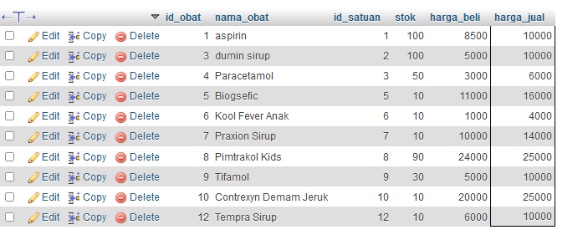

SELECT nama_obat, stok FROM `obat` WHERE stok='10'

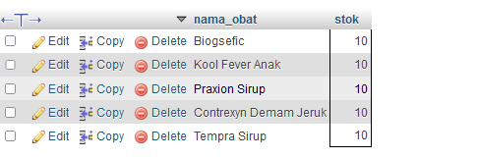

SELECT * FROM obat

WHERE nama_obat ='Paracetamol' OR nama_obat ='aspirin';



SELECT * FROM obat

WHERE nama_obat ='paracetamol' AND harga_jual ='6000'

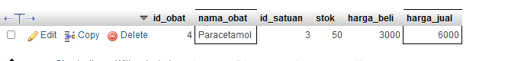

SELECT * FROM `obat`

WHERE nama_obat='Tifamol' AND (stok ='30' OR stok ='40');

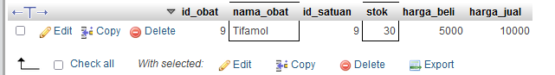

SELECT * FROM penjualan_detail WHERE qty

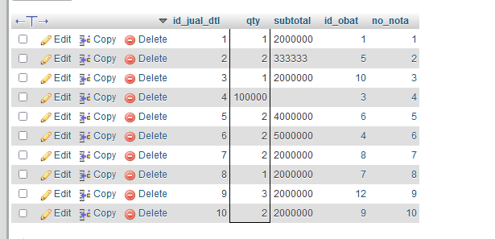

SELECT qty, subtotal FROM `penjualan_detail` WHERE qty='1'

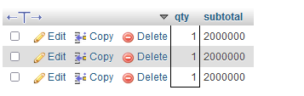

UPDATE obat

SET stok='20'

WHERE nama_obat='paracetamol';



UPDATE obat

SET nama_obat='aspirin';

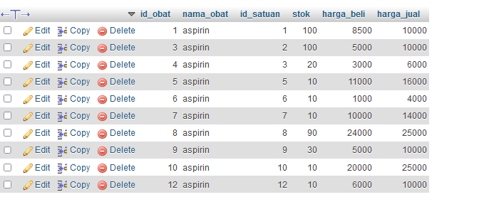

DELETE FROM pembelian WHERE total='4000';

